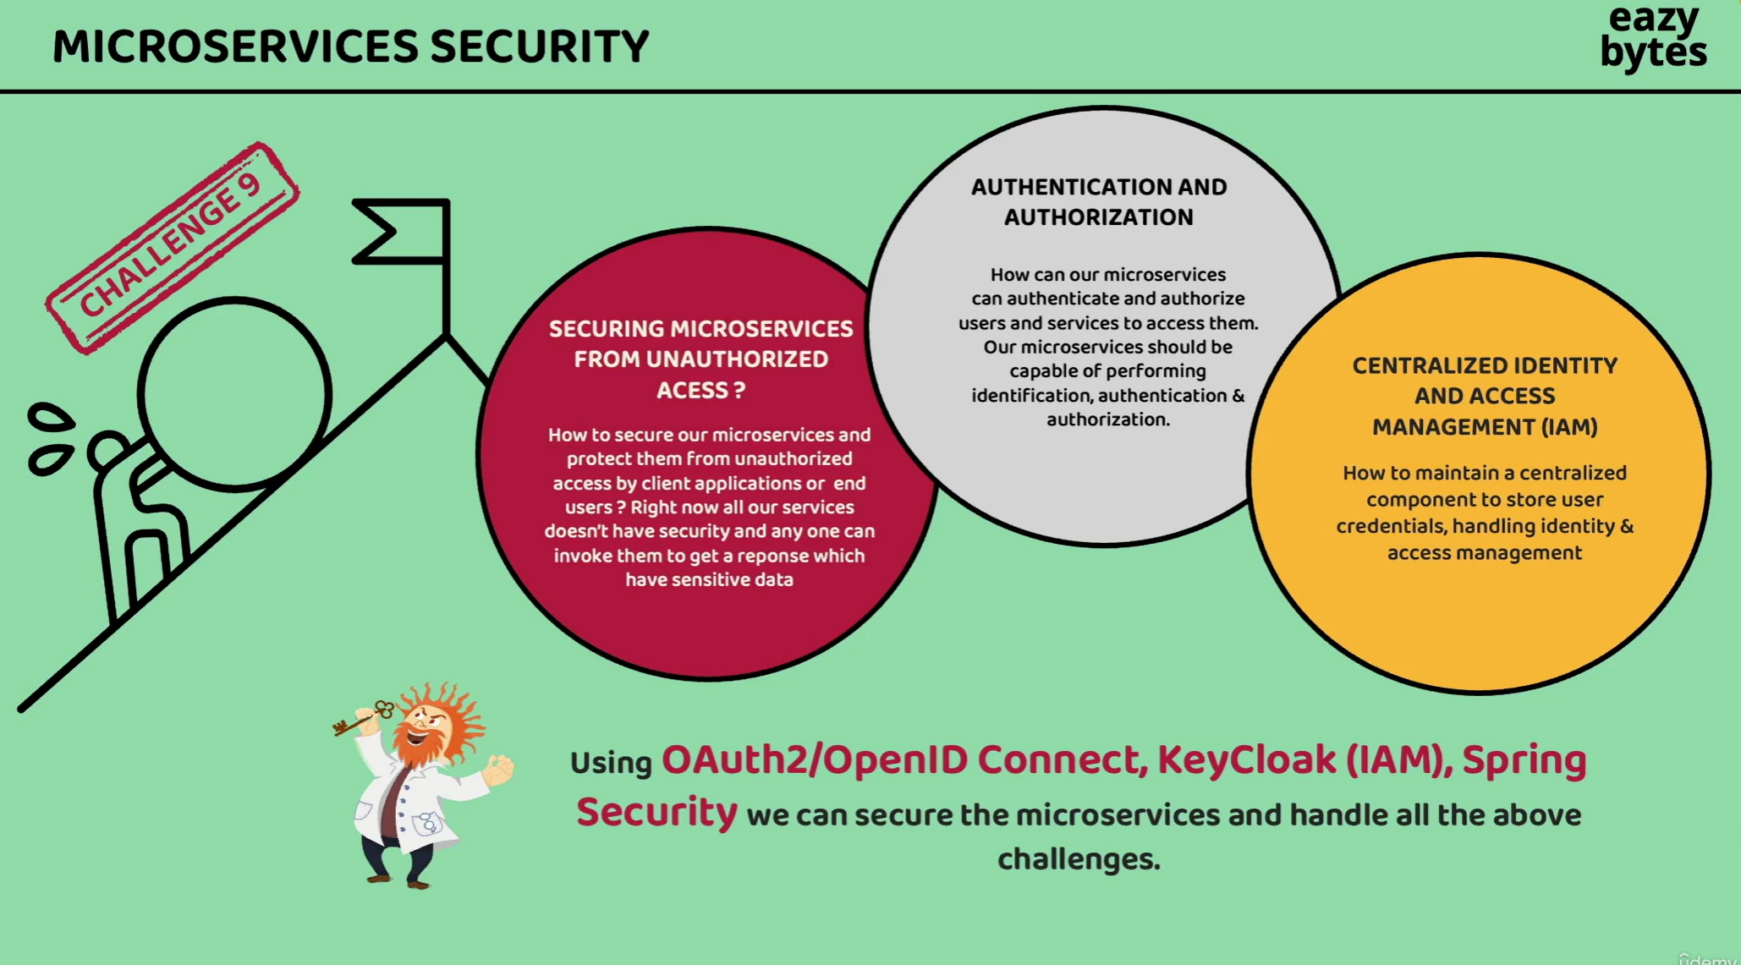

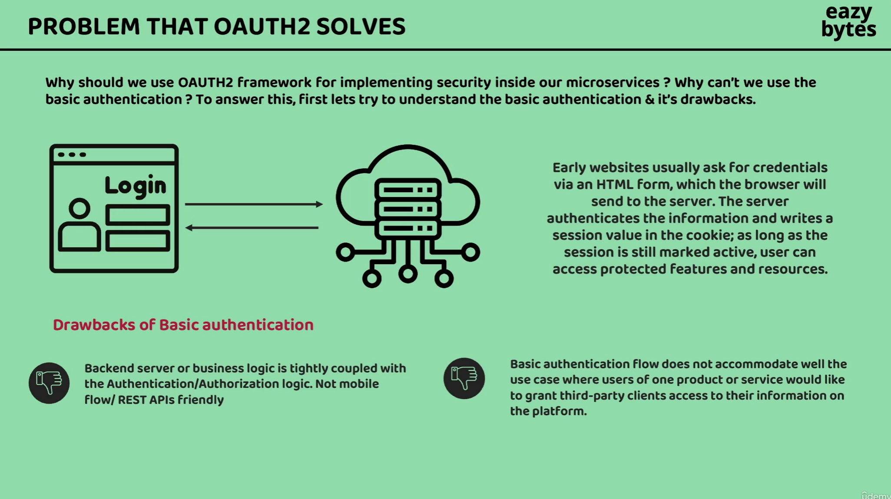

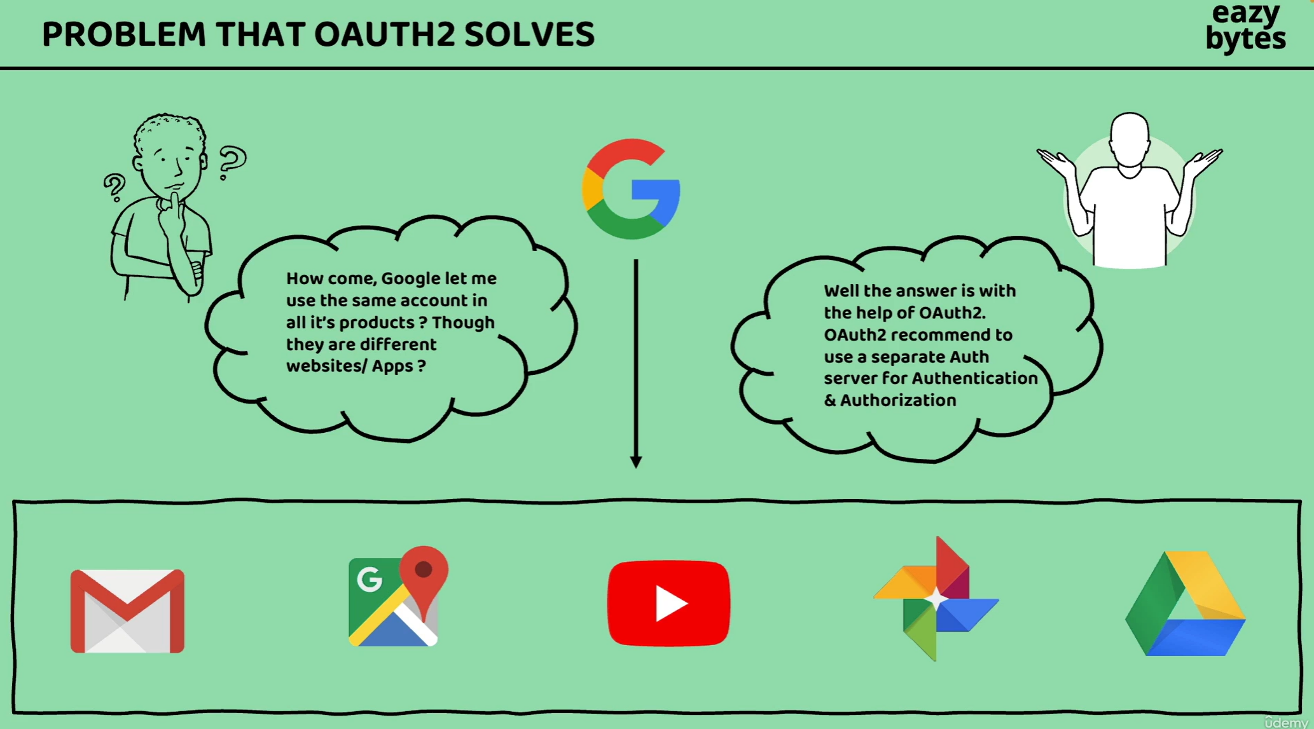

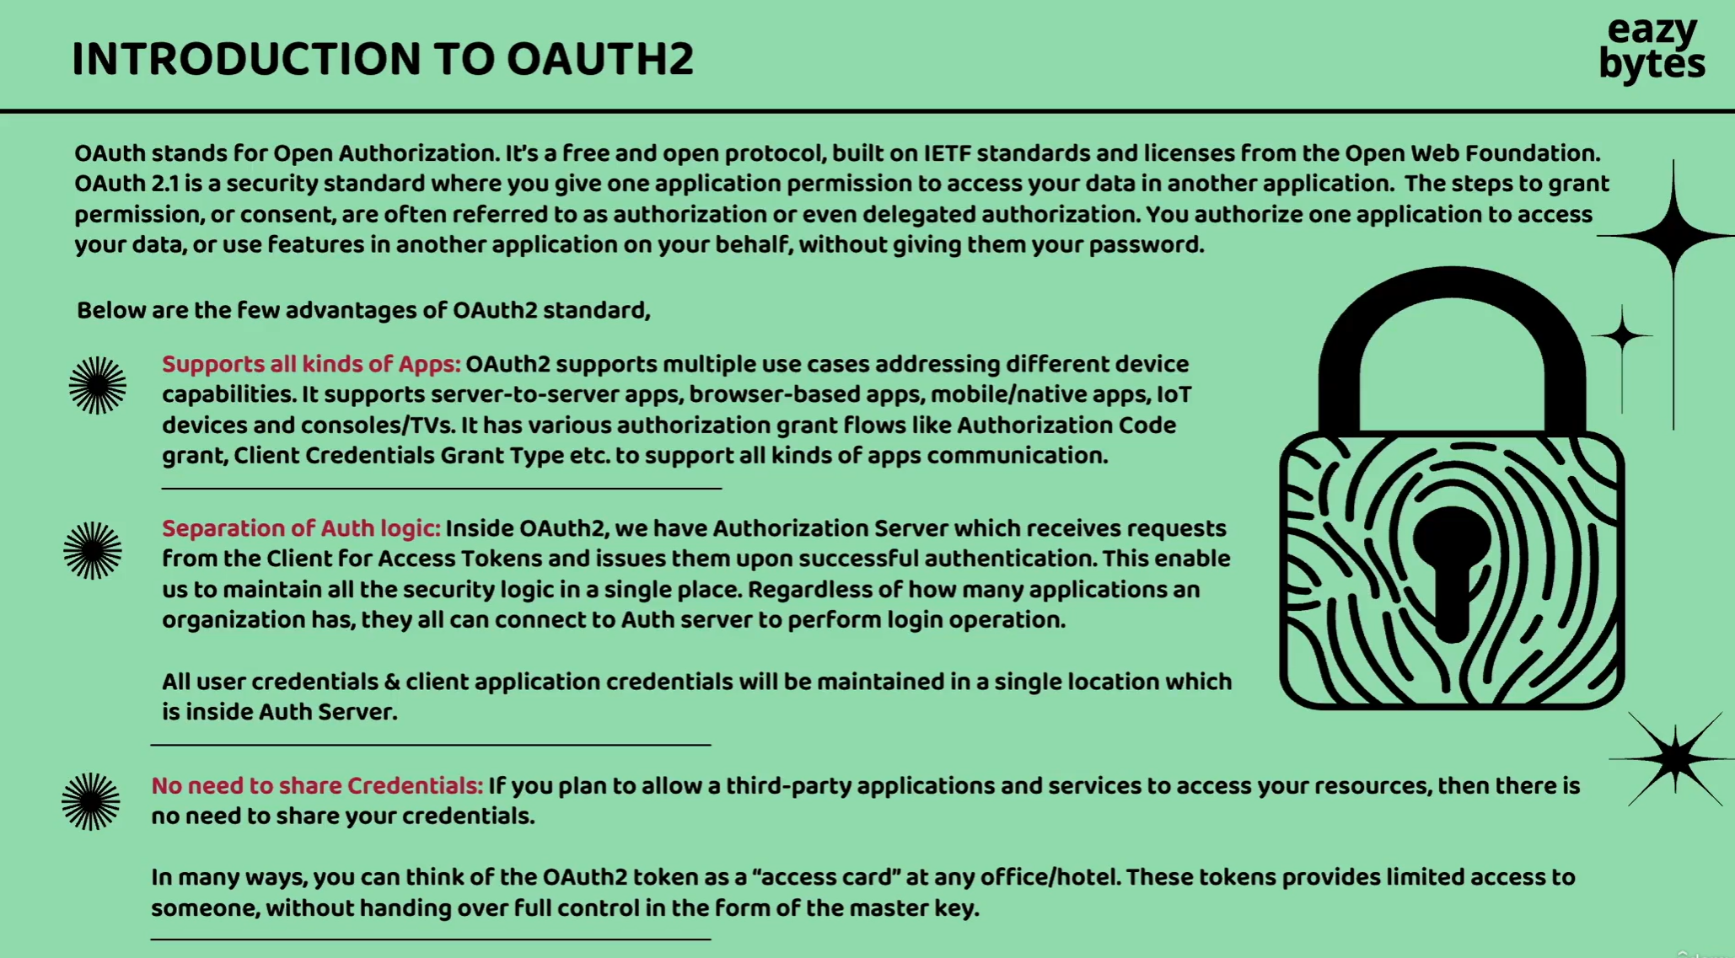

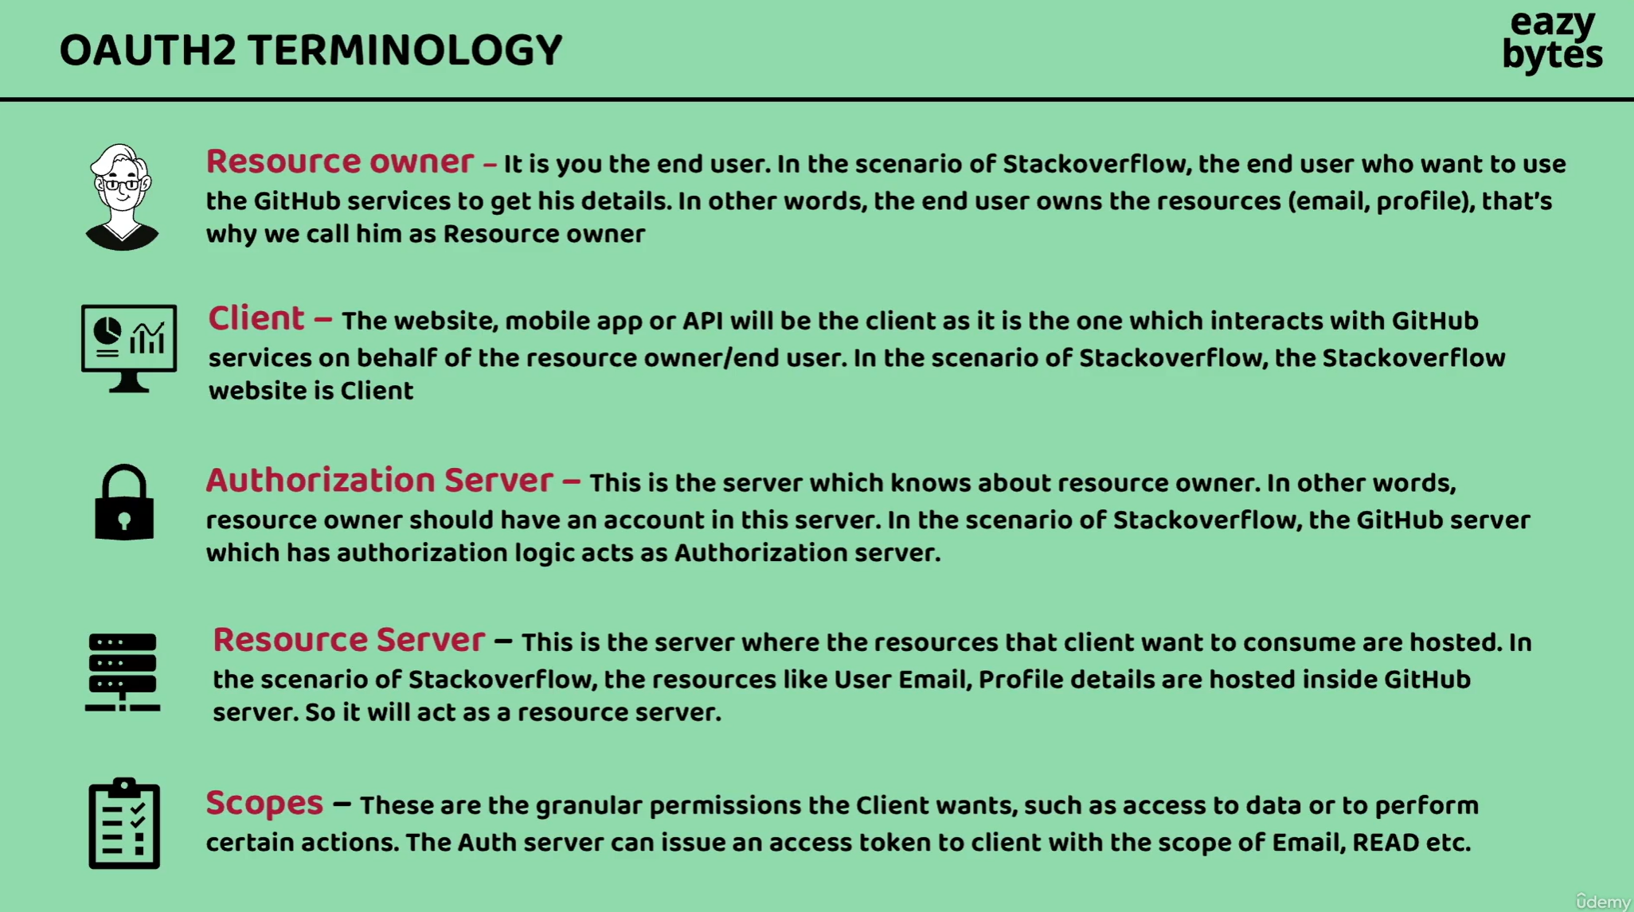

Usually inside enterprise organizations like GitHub, Google or Facebook or any other organizations,

They will have separate servers handling the authentication and storing the resources of the end user.

So, in other words, my authorization server is responsible for authentication the resource owner and once the authentication is successful, my authorization server is going to issue an access token to the client.

Using the same access token the client application is going to send a request to behind the scenes to the resource server.

If the resource server is satisfied with the validity of the access token, then it is going to give the resources of the resource owner.

Example of scope

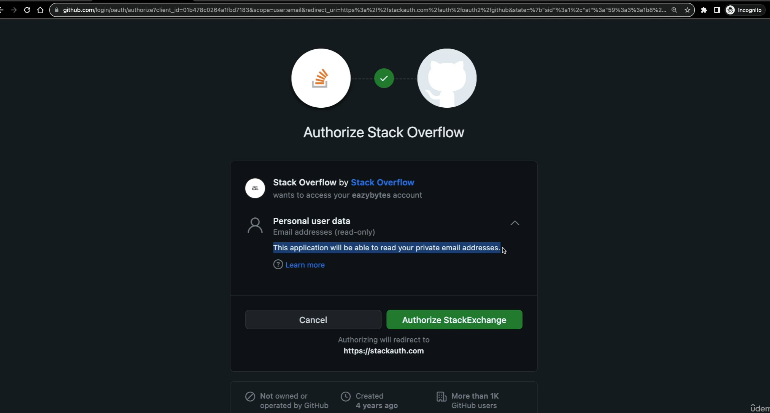

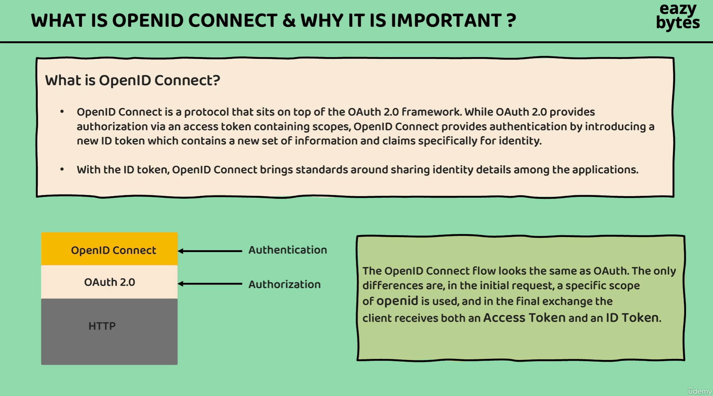

Organizations started using Oauth2 framework both for authentication and authorization and OAuth2 framework is going to issue an access token.

And with this access token, the client applications, they can only access the protected resources that are present behind the resource server.

**And this access token does not give any clue about who is the end user, what are his details**.

Since the client applications do not have concrete information about the resource owner or end user, lot many organizations they used to share the details about the end user inside this access token only by sending his email detail or by sending his mobile number. Everyone used to follow their own style of sharing the end user details inside the access token.

**So, since there is no standard, everyone in the industry felt that we need some better approach to know the end user or resource owner details inside the OAuth2 framework.**

**That’s why they build a small wrapper on top of OAuth2, which is OpenID.**

**So whenever we use OpenID along with the OAuth2, we’re also going to get an extra token with the name ID token** and with this ID token and OpenID Connect, the industry now has a standards around sharing the identity details among the applications.

When we implement these OAuth2 and OpenID Connect inside our microservices, I’m going to show you the access token, ID token that are issued by the server.

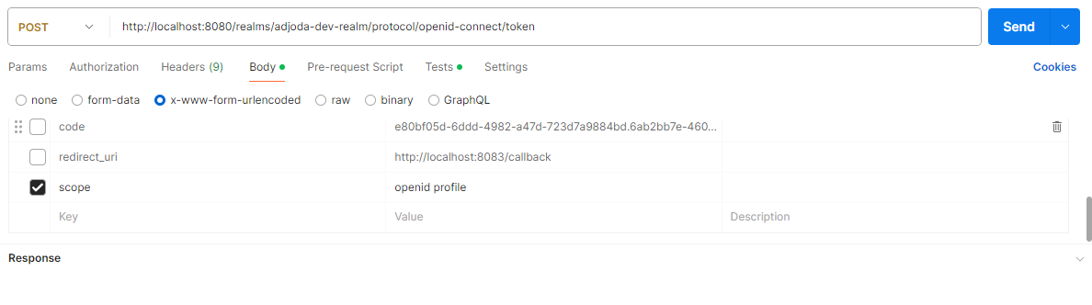

Whenever we are using OpenID Connect, we need to send a scope which is OpenID and behind the **scenes the Auth server by looking at this OpenID scope, it’s going to issue two types of token. One is access token and ID token.**

**If we don’t send the scope OpenID, we’re going to simply receive the access token.**

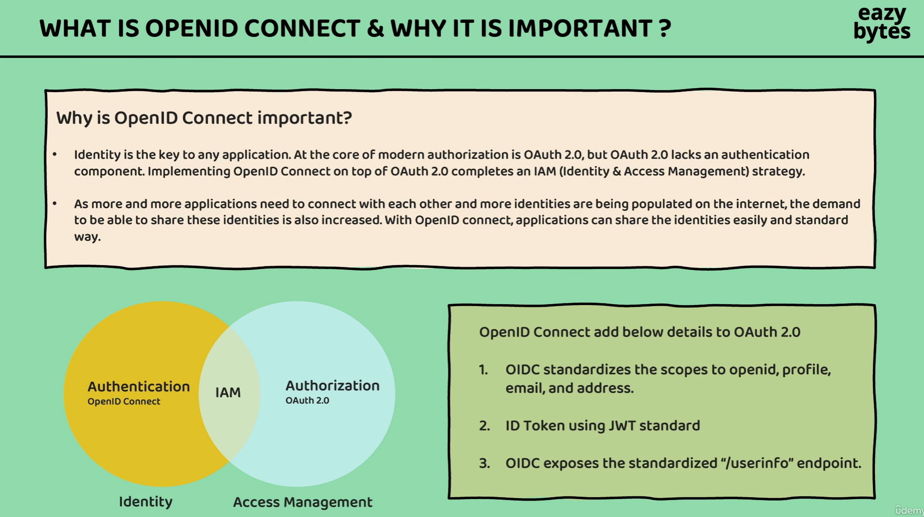

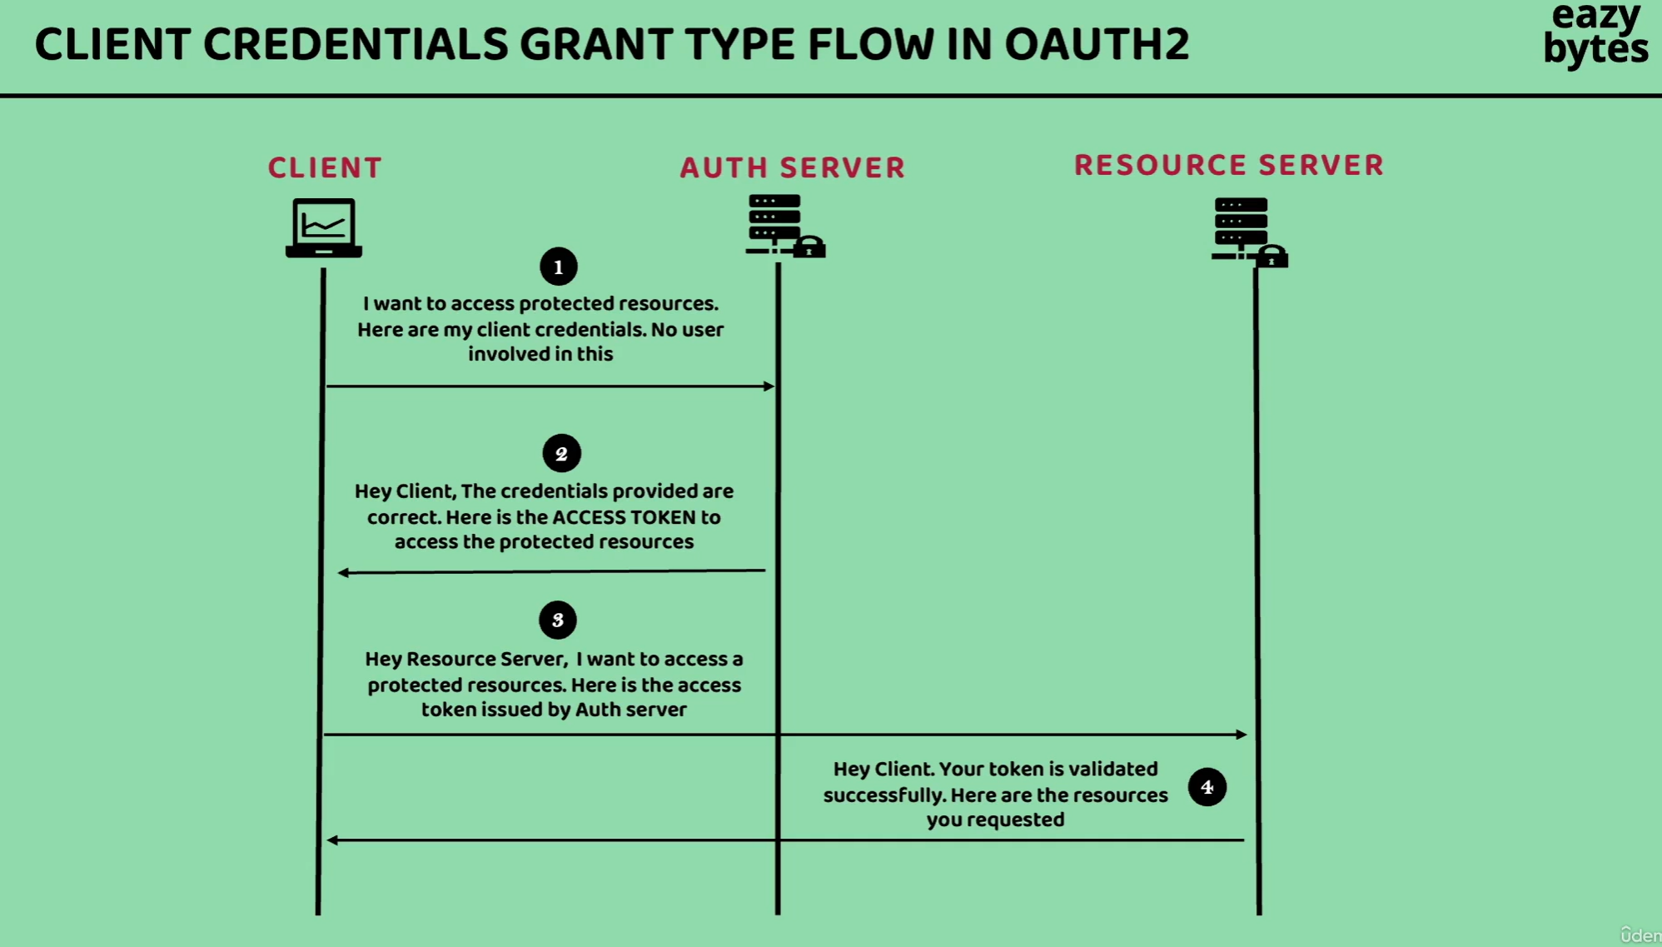

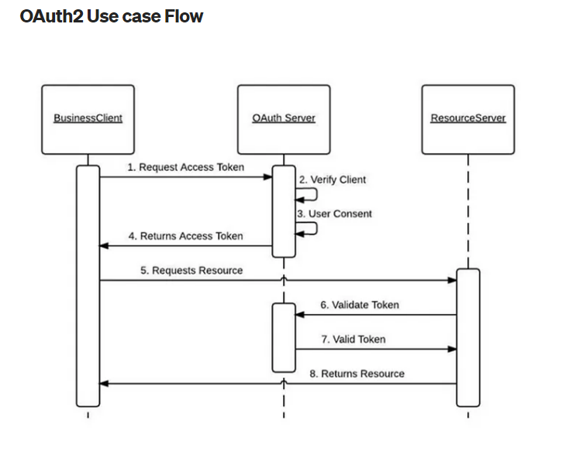

**The resource server or the gateway server is going to send the response only if it receives the proper access token from the client application that is issued by the auth server.**

**Once the access token is received by the client application, the client application is going to send the same access token to the resource server. Along with the access token, it will also convey which resource is trying to access.**

**Now the resource server will take that access token and behind the scenes it will validate the access token with the auth server and if the client application has enough privileges to invoke that particular secure API or secure resource, then the resource server is going to respond to the client.**

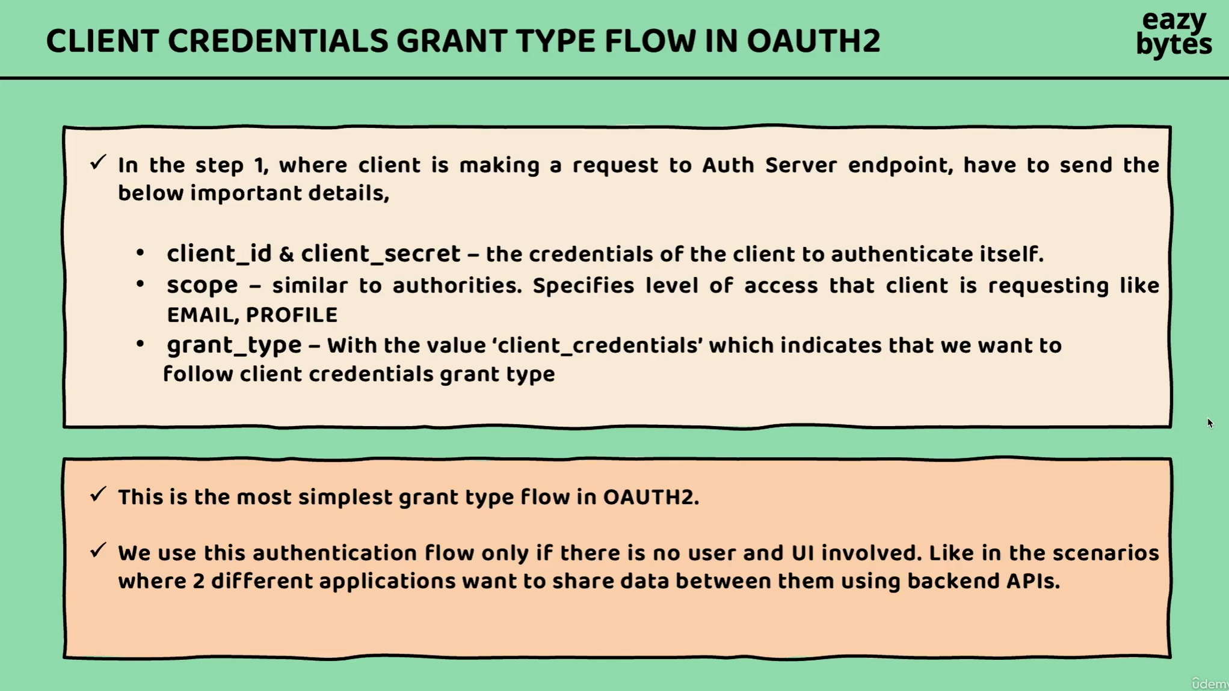

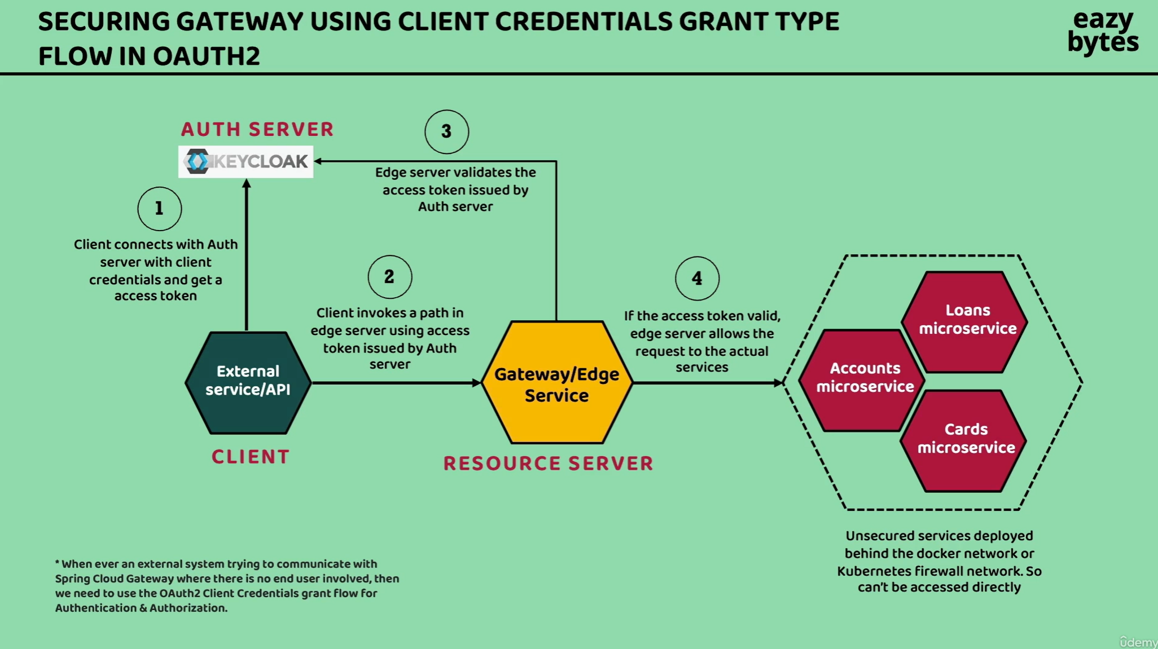

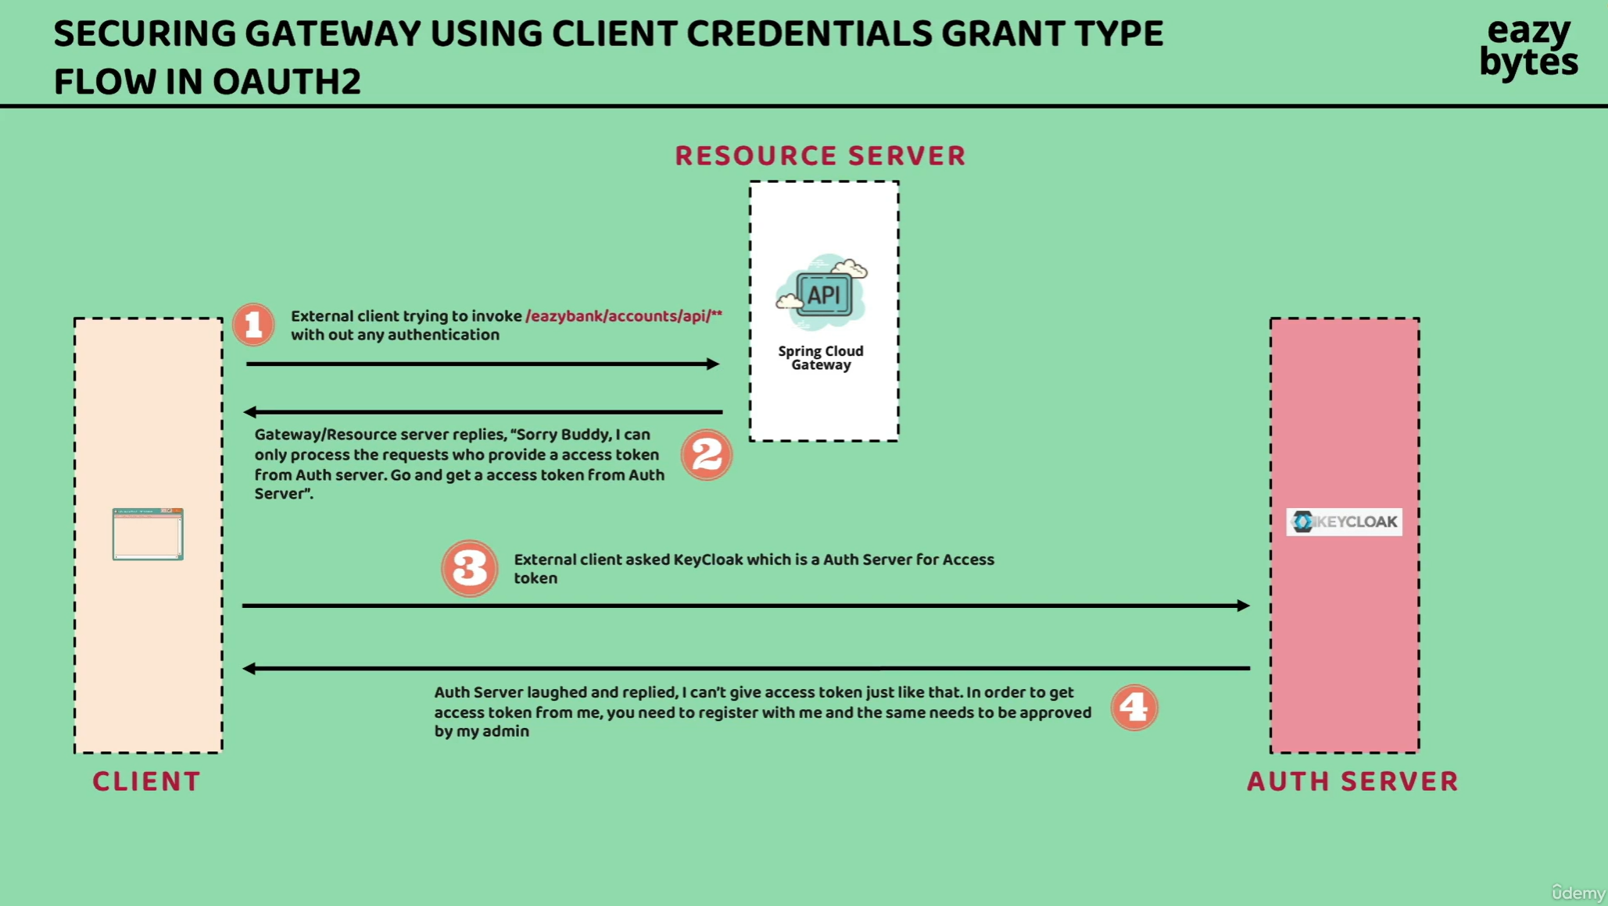

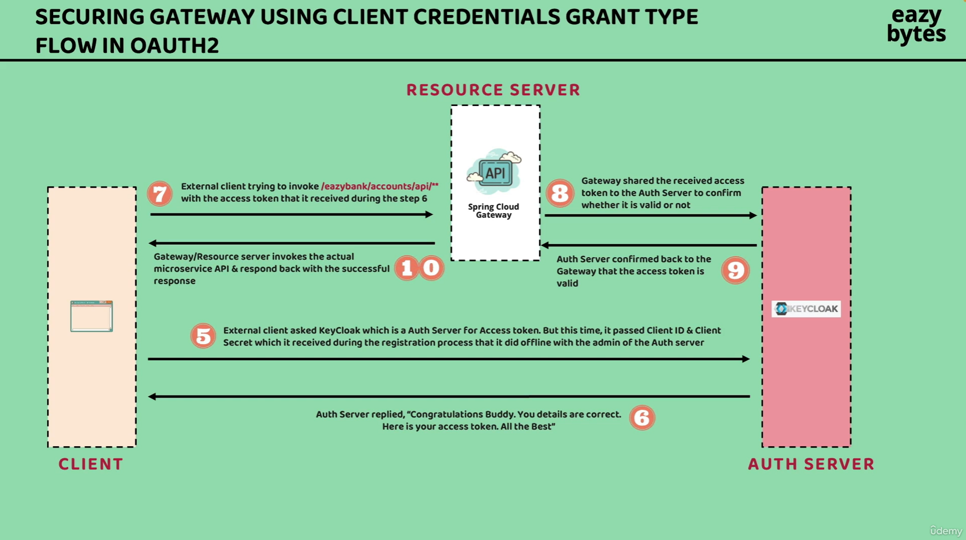

**If the keycloak supports OpenID Connect also in such scenarios, along with the access token, the client also going to get the ID token as well.**

**Setup OAuth2 server.**

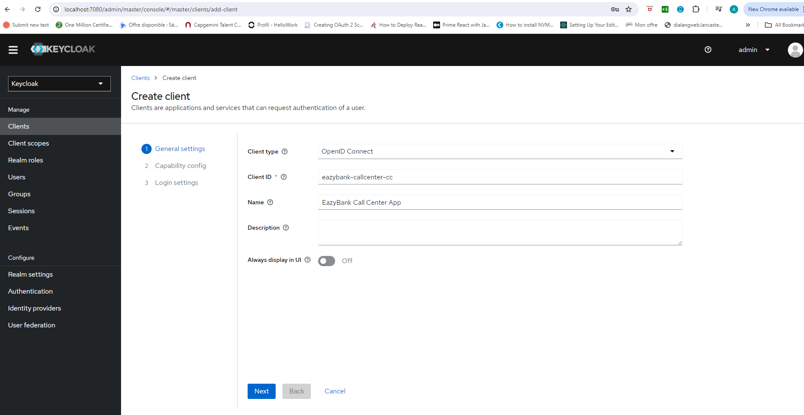

**OpenID Connect is a wrapper that is built on top of OAuth2 framework.**

**eazybank-callcenter-cc: the cc indicates this is the client ID that I have created for client credentials grant type flow.**

**So the cc indicates clients credentials.**

**Client credentials grant type flow**

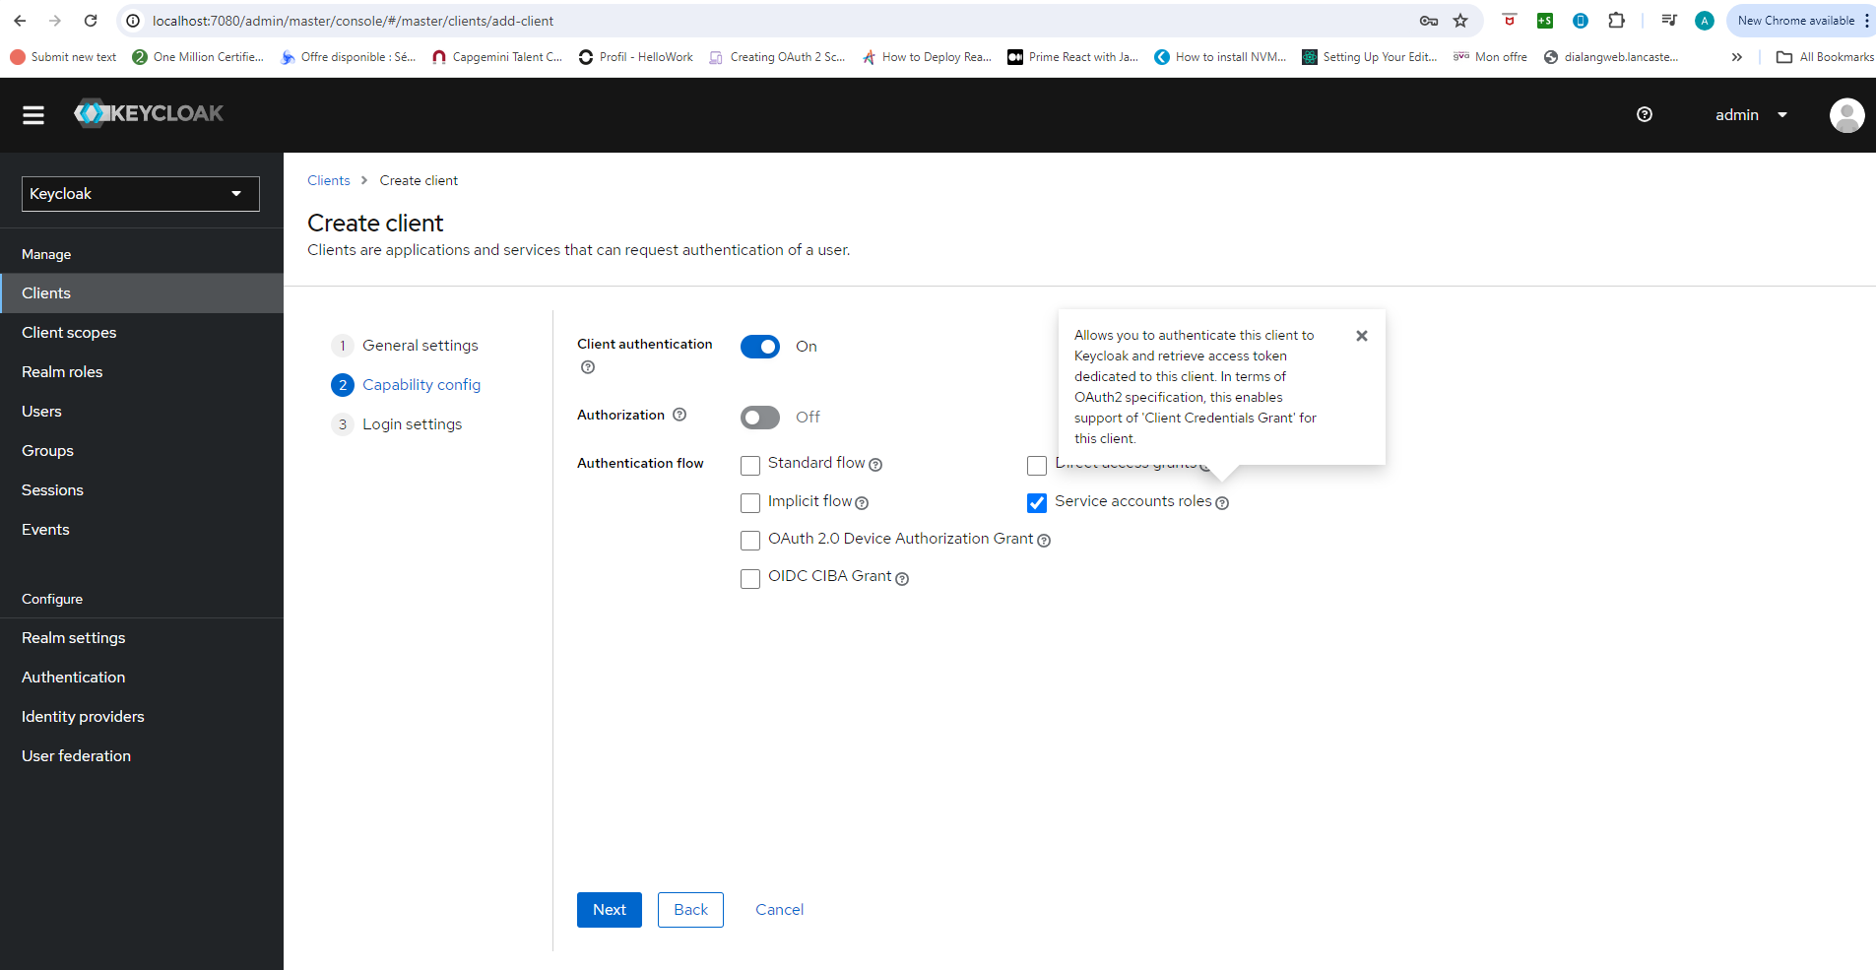

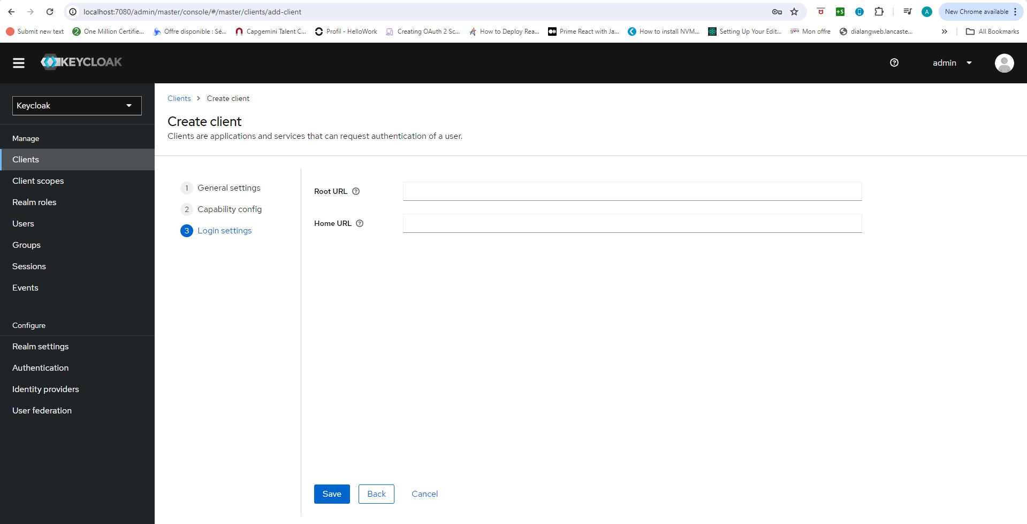

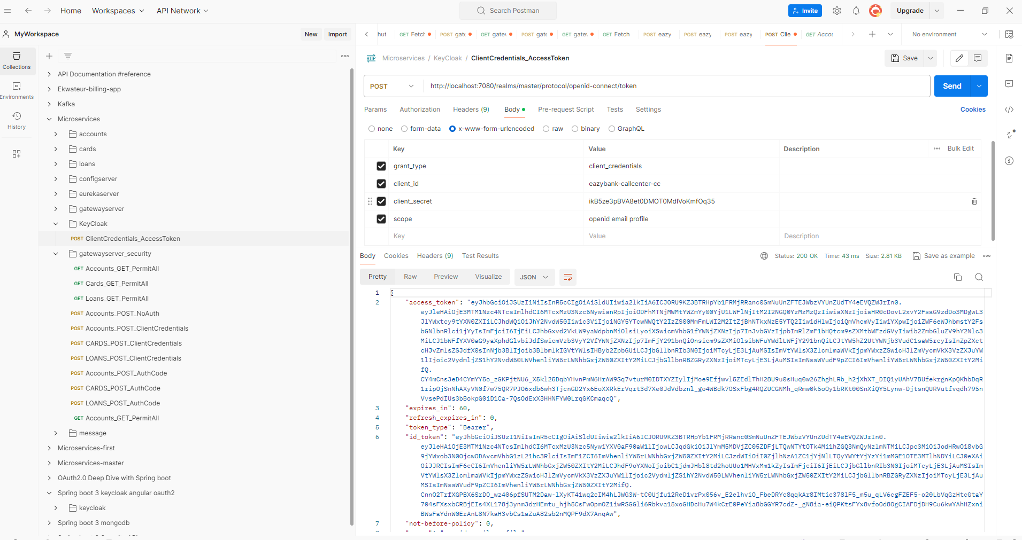

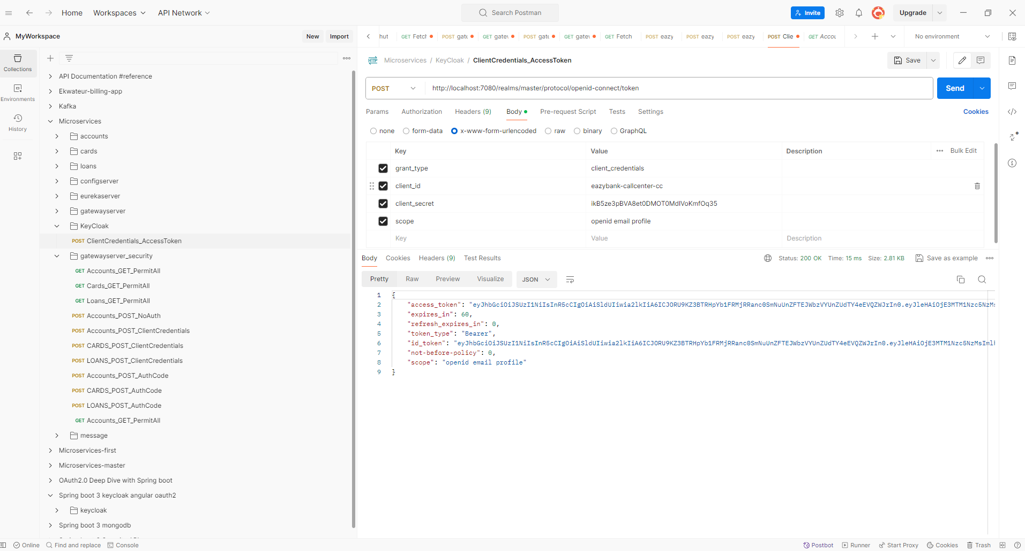

{

    "access_token": "eyJhbGciOiJSUzI1NiIsInR5cCIgOiAiSldUIiwia2lkIiA6ICJORU9KZ3BTRHpYb1FRMjRRanc0SmNuUnZFTEJWbzVYUnZUdTY4eEVQZWJrIn0..RKGO8bfO088S2R0wx8nZrFebeEXxUxQb-krboqKkmZBGbKY085nTBFwEEaalJLnvNUOaYQqGpsXVoqM_DumQrLC9z13jE-v7_mWp23kDTUf1Ark97yRDWilXC1nyIH2vA9qzTkN_ZTNrLP73mgBQPBUbtHdWhTOSw1ZJ5DNV1Vm2J4Dy1QIJZq0BezEXZLlVrs2VmUsG8JYZqqhKJ-Jt9RFk0MB2zp6hrTR72mhF0BXOpvnl0otD_gabkgc56swqn1Y2CTagAx76vt-kpc6EtKgMA16Es26iMBuXy2UwwC1CZEncib-XM2Fk82JUSp0M8vspPVIHVzlRpC-c15LEoA",

    "expires_in": 60,

    "refresh_expires_in": 0,

    "token_type": "Bearer",

    "id_token": "eyJhbGciOiJSUzI1NiIsInR5cCIgOiAiSldUIiwia2lkIiA6ICJORU9KZ3BTRHpYb1FRMjRRanc0SmNuUnZFTEJWbzVYUnZUdTY4eEVQZWJrIn0..nGqBaKsCB8ivdXXBpjUKpnd4cVljfRoY1QqzGceNaAfgQQfycQR_2-H2_VS-o8-ZlRwLstPJqCQu0MO4lyhjBTgsyAxK0Tdxh47ZmptxSNcEBBOwqPdF6lWkPCQR6U8YNEi18JK-M23aqzubQs8u76waxx-VDpqeDxHGnhyRUDhNurdEkbaKiG_dWiE0TqZP8HlmTCzY_m884ATyT_WSrlsnTnDJInAAfoyTcEc45Q5qymr22nvqtDCYuJy1Oc6qHG063BAZlIGXmzesFckmNc8ZA5NzZ7VU4M6-t44MkdLJy9mK56zJVbc_oKiI3Z47cbzY1v_UYFPArZxc1bgb_Q",

    "not-before-policy": 0,

    "scope": "openid email profile"

}

**In real projects the client application will try to invoke this API with this body from their Java or from their backend code.**

**And with that they will be able to successfully get an access token and using the same access token they are going to invoke the resource server.**

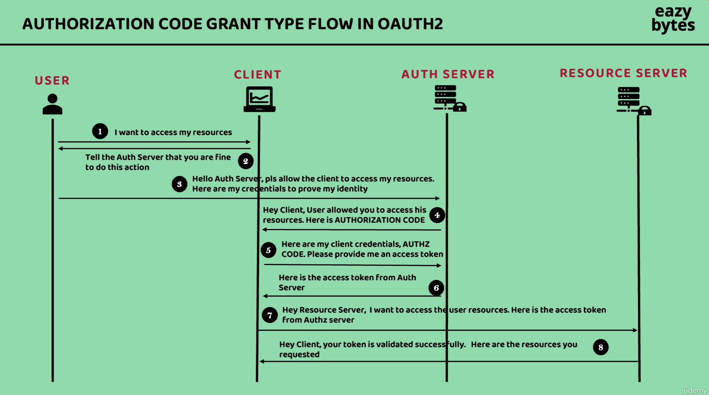

**If there is a UI application or a mobile application, there will be an associated end user who is trying to use that website or mobile application.**

**So in this kind of scenario, we should use authorization code grant type flow which is available inside OAuth2 framework**

**Once the auth server validated the end user details, it is not immediately issuing an access token, to the client application because it has to validate the client credentials as well.**

**That’s why it’s going to issue an temporary authorization code using which the client application has to send the request again this time with the client credentials as well.**

**If the client credentials and authorization code is valid, then only it is going to issue an access token.**

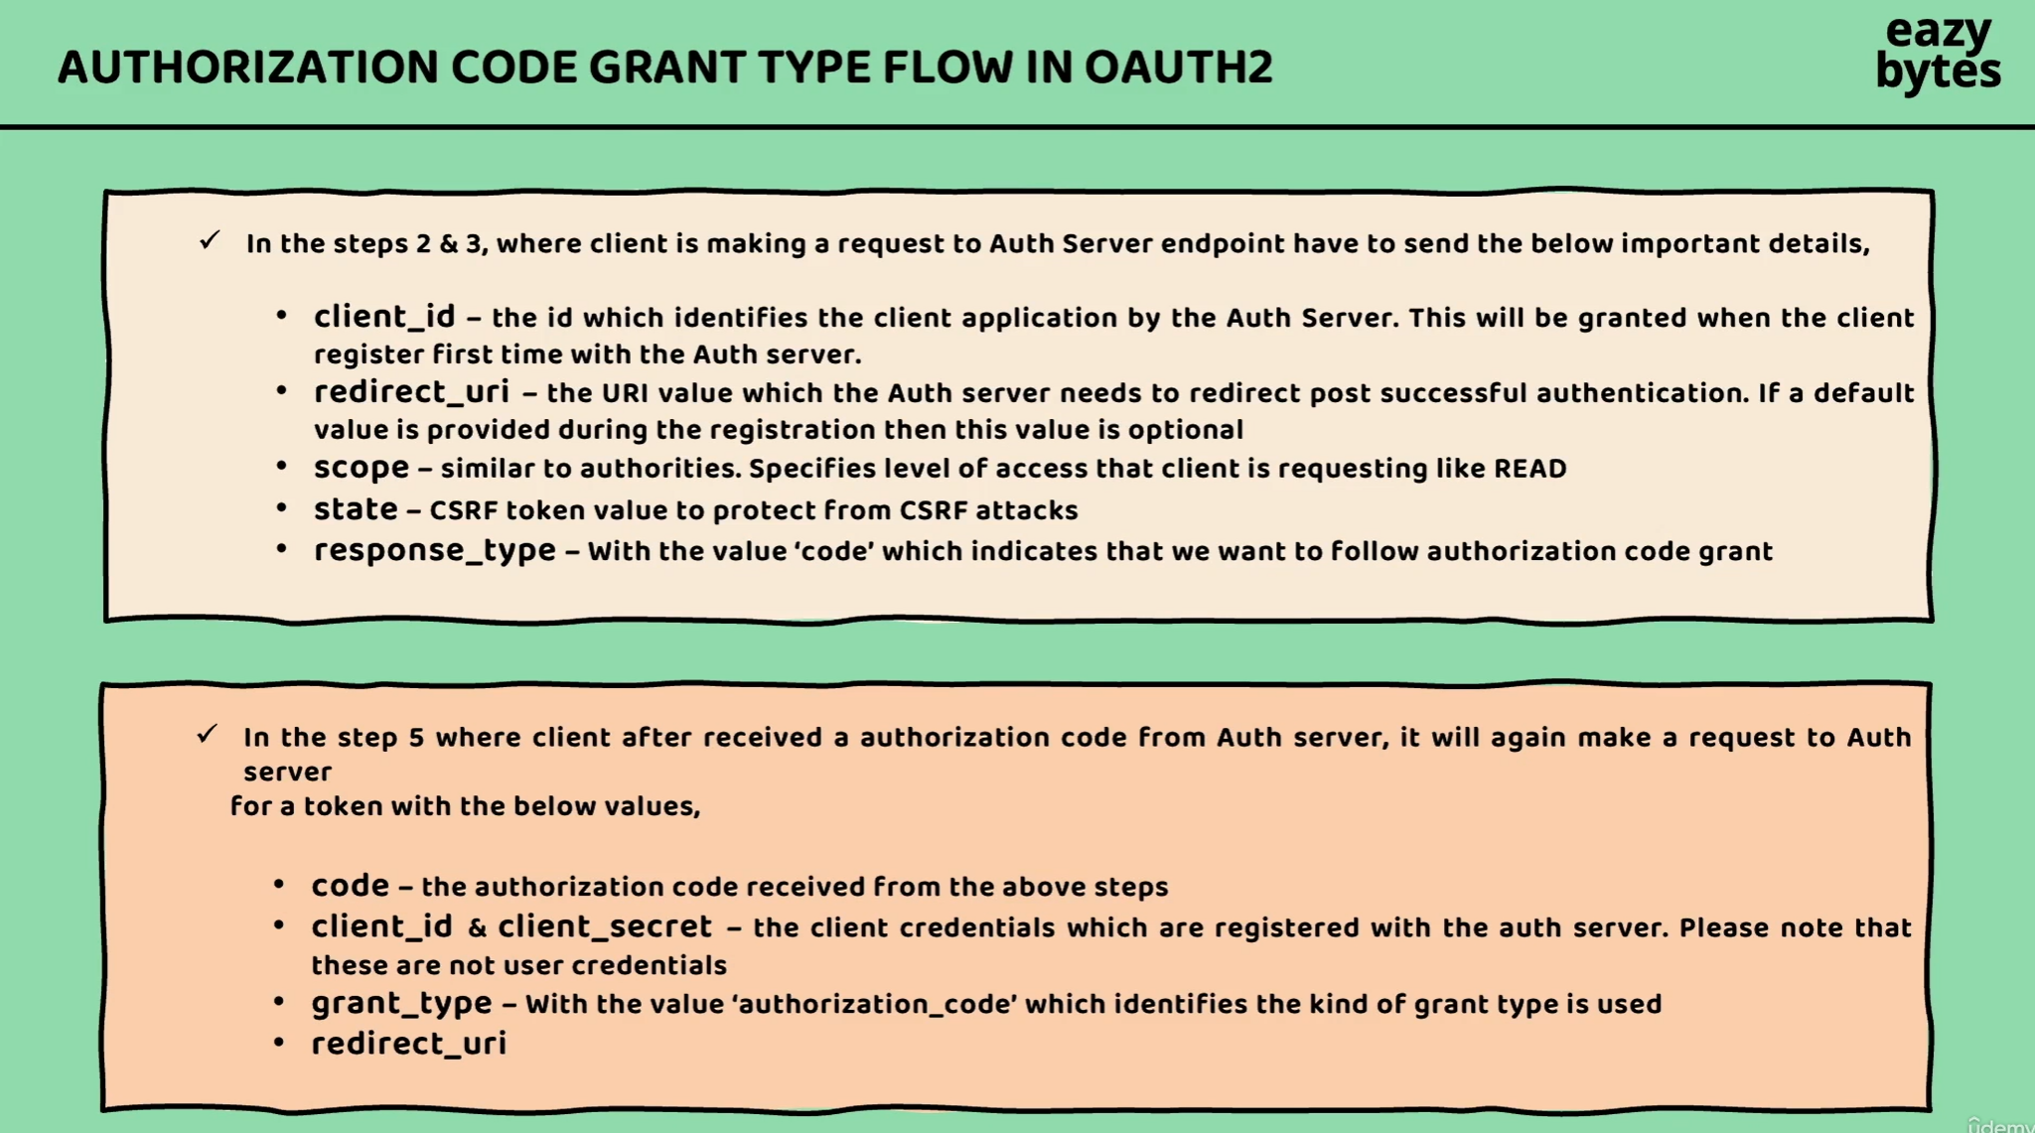

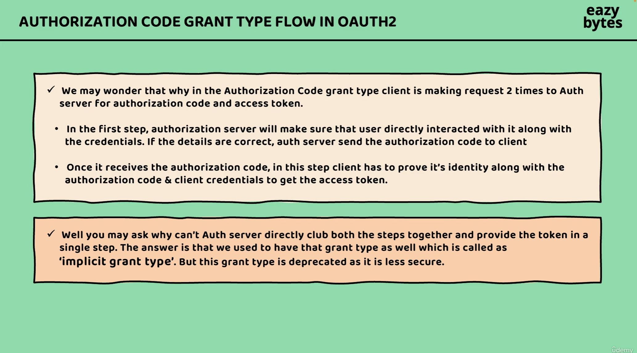

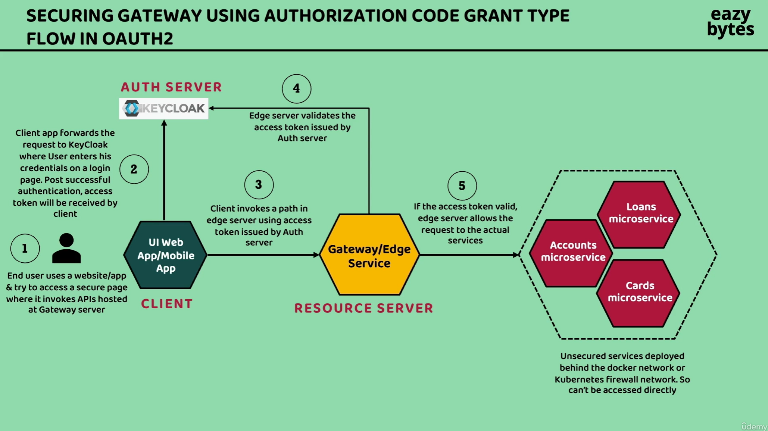

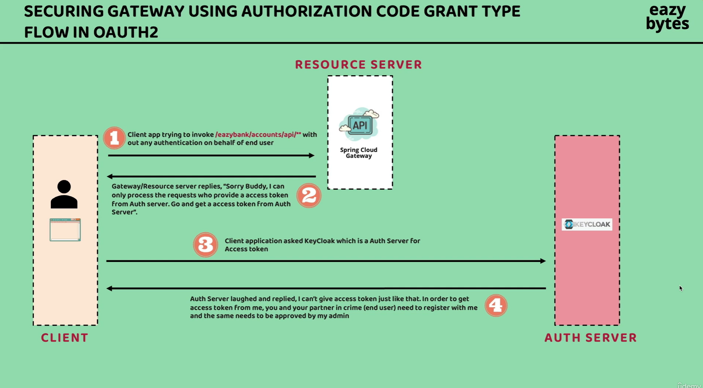

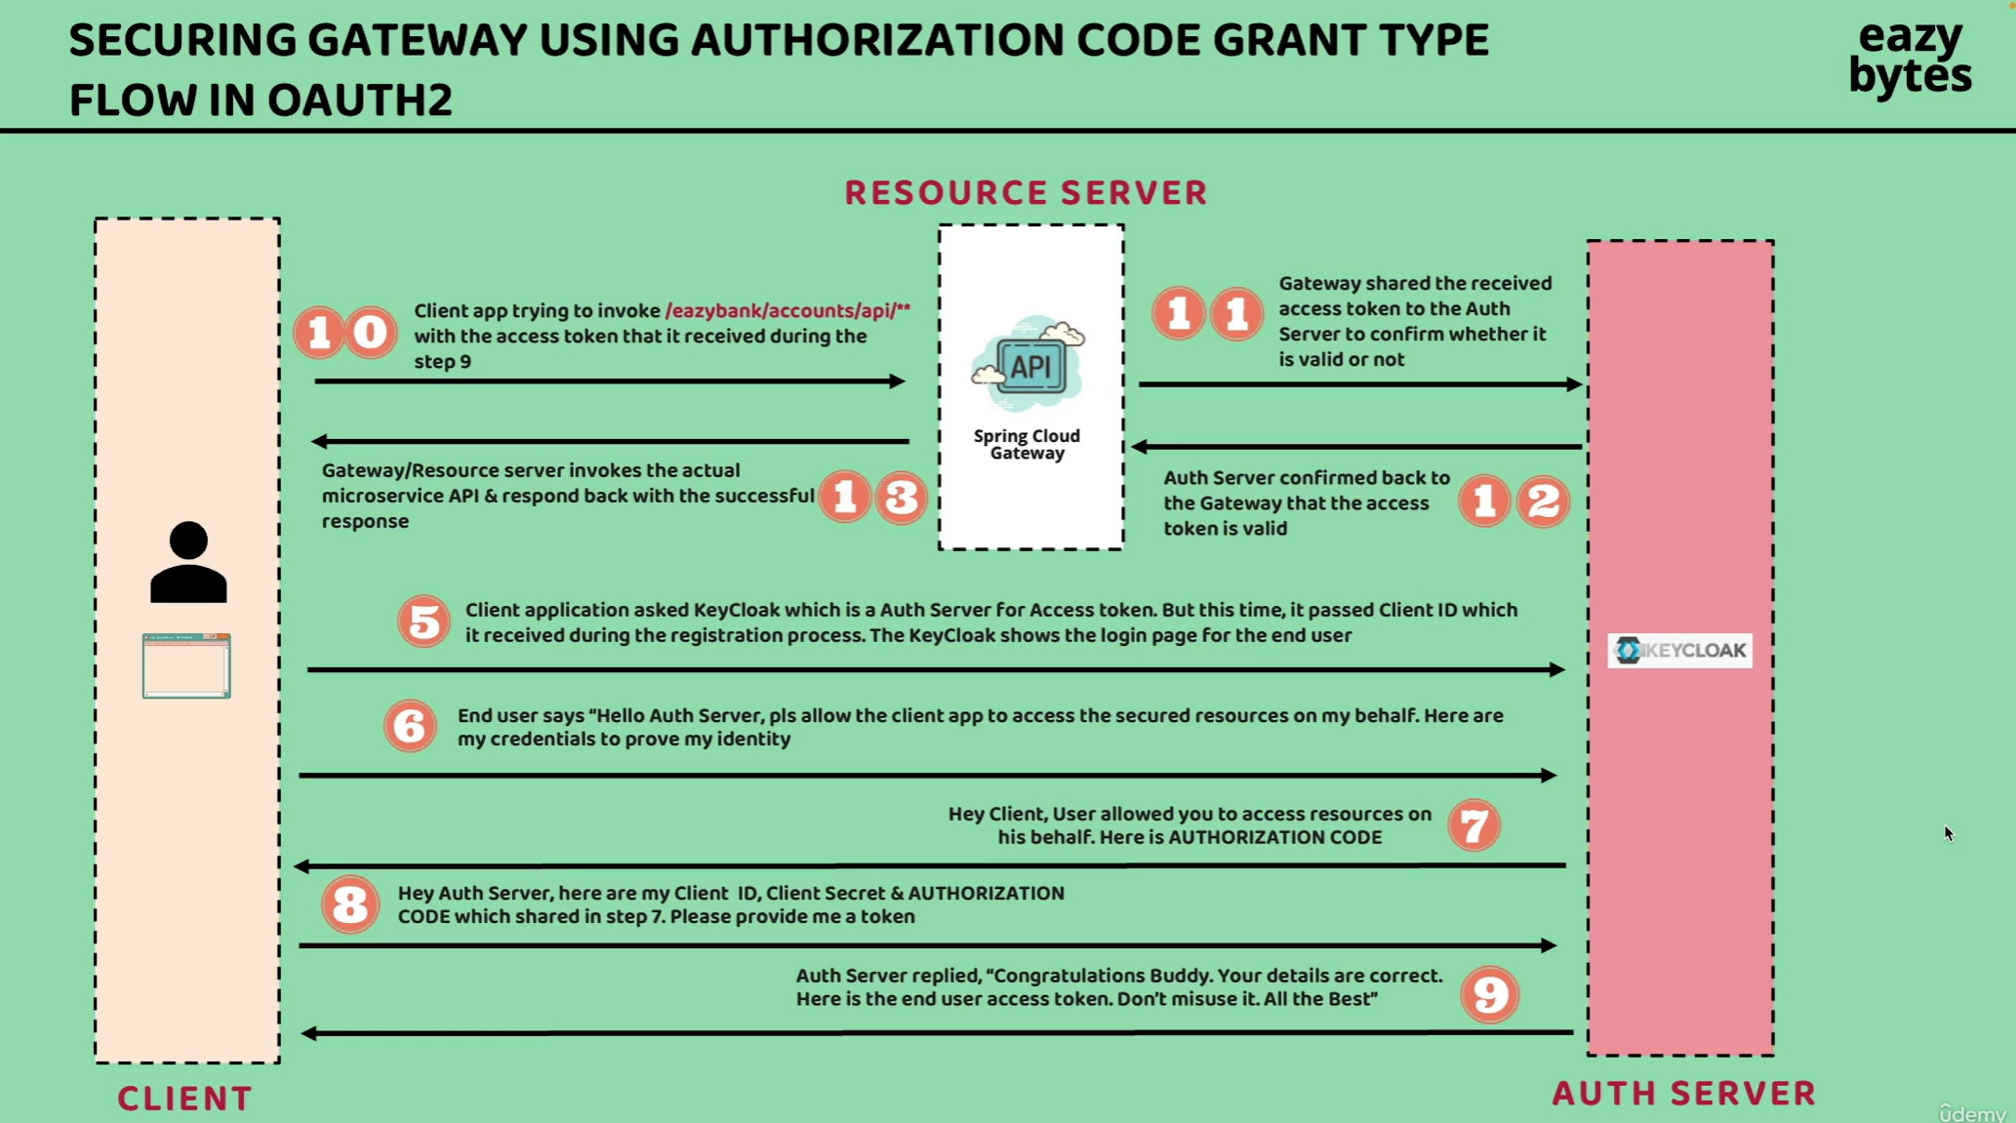

**Register client & end user inside keycloak for Authorization code grant type**

